Breaking the Windshields[1]

Krishna Kant is intent on becoming a regular supplier to Kaveri Automobiles. He has already tied up with two of the six major automobile manufacturers for the supply of windshields. The requirements of each automobile manufacturer are different in terms of the size, shape, curvature and of course, strength. His company boasts the latest in flexible manufacturing. He also knows that Kaveri *has* a fairly large requirement and the supplier is a major competitor. He arranged for a special meeting with Basava Raj, Vice President of Kaveri.

Basava Raj is not very enthusiastic in changing the suppliers. "We are very happy with our present supplier. His quality is very consistent, and we don't have to test his materials. He always supplies on time. We keep only 15 days inventory". Krishna replied immediately, "1 can reduce your inventory to less than 7 days and deliver the material at your door step at my expense".

"But your windshields are two and half percent more expensive and that will more or less nullify the advantages of lower inventory", retorted Basava Raj. "True, but you will be getting better windshields. Ours are rated at 500 psi. That is definitely better than your present supplier and you don't have to take my word for it. I will supply a few samples and you test them yourselves. Just tell me how many you need for testing", replied Krishna Kant.

Later in the day, Basava Raj had a meeting with Rammurthy, his quality control manager. The current supplier's windshields are rated at 470 psi only. The variance is also fairly high at 2500 psi2. Rammurthy said that they can assume the same variance for Krishna Kant's windshields also. At the same time, the sample size should not be too large, since the tests involved are destructive. They have decided to test the null hypothesis that the average strength of the new windshields is at least 500 psi, as claimed by Krishna Kant and that the error level in rejecting the null hypothesis could be about 10%. They have agreed that it would be more serious not to reject the claim, if it is not really true and hence decided that such an error should be limited to only 5% with the current supplier's parameter being the bench mark.

Rammurthy said that he will get in touch with Krishna Kant and inform him about the number of windshields required for the test and also tell the lab about critical values for rejecting or not rejecting the new supplier. What should be the instructions to the lab? How many windshield should the lab test?

# Choosing the Null and Alternate Hypothesis for new vendor

There are two choices of choosing the null hypothesis:

|  |  |  |
| --- | --- | --- |
| **Null Hypothesis choice 1** | | |
|  | **mu of new windshield >= 500 psi** | **mu of new wind shield< 500** |
| **Conclude mu >= 500** | Implication: Take the new vendor | Type 2 error Implication: Unnecessarily fired old vendor |
| **Conclude mu < 500** | Type 1 error Implication: Settled for lower quality of older vendor | Implication: Continue with current vendor |
| **Null Hypothesis choice 2** | | |
|  | **mu <= 500** | **mu > 500** |
| **conclude mu <= 500** | Implication: Continue with current vendor | Type 2 error Implication: Settled for lower quality |
| **conclude mu > 500** | Type 1 error Implication: Unnecessarily fired old vendor | Implication: Take the new vendor |

Now out of the two hypothesis it seems we have to settle for Null hypothesis choice 1 because of following reason: Error of settling for lower quality has higher impact than firing older vendor for lower quality. Hence we would want to keep that in Type 1 error rather than type 2 error.

# Acceptance and rejection bands for new vendor

For new vendor:

H0: Strength of windshield >= 500. Thus we will reject if and only if we find sample statistics with mean lesser than the rated mean as determined by the CI: Red denotes rejection region and green denotes acceptance region:

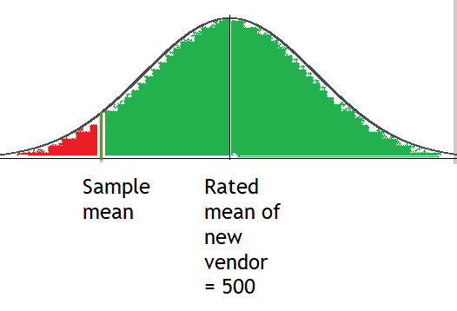

As per problem statement it is mentioned that area of red region should be < 10%.

# Choosing null and alternate hypothesis for old vendor

Again two choices:

|  |  |  |
| --- | --- | --- |
| **Null Hypothesis choice 1** | | |
|  | **mu of old windshield >= 470 psi** | **mu of old wind shield< 470** |
| **Conclude mu >= 470** | Implication: Continue with current vendor | Type 2 error Implication: Settle for low quality. No complain to old vendor as this was already rated. |
| **Conclude mu < 470** | Type 1 error Implication: Fired the old vendor | Implication: Take the new vendor |
| **Null Hypothesis choice 2** | | |
|  | **mu of old <= 470** | **mu of old > 470** |
| **conclude mu <= 470** | Implication: Take the new vendor | Type 2 error Implication: Fired the old vendor |
| **conclude mu > 470** | Type 1: Error  Implication: Settle for very low quality. No complain to old vendor as this was already rated. | Implication: Continue with current vendor |

Here also if we see that the implication: Settle for very low quality. No complain to old vendor as this was already rated. is very high. So we want to keep it under type 1 error to minimize it. So choose Choice number 2

# Acceptance and rejection regions for old vendor

Though we are not testing for sampling the old vendor’s products but we need to find the optimum point of operation in order to estimate number of samples:

We will reject the null hypothesis that **mu of old <= 470** if we get a sample with strength so high determined by the CI.

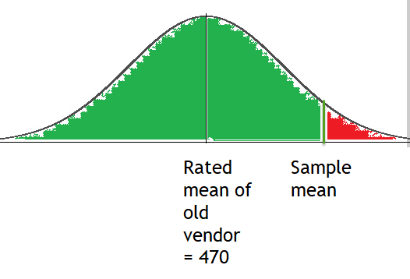

As per problem statement area of red region = 5%. Thus we have to find n such that it satisfies both the criteria.

# Calculations

1. Let number of samples be n
2. New Vendor: μ = 500; σ = 50 (Considered same as previous vendor); α = 0.10; Thus inferred
   1. |Z0.1| = ABS(NORM.INV(0.1,0,1)) = 1.281
   2. Point of operation on X axis: x = μ - σ/sqrt(n)* |Z0.1| = 500 - 50/sqrt(n)*1.281 …. (i)
3. Old vendor: μ = 470; σ = 50; α = 0.05; Thus inferred:
   1. |Z0.05| = ABS(NORM.INV(0.05,0,1)) = 1.645
   2. Point of operation on X axis: x = μ + σ/sqrt(n)* |Z0.05| = 470 + 50/sqrt(n)*1.645 … (ii)
4. Equating both the equation we get: n = 23.78 ~ 24 windsheilds

1. V. Nagadevara, Indian Institute of Management Bangalore